# CS 255 System Design Document

## UML Diagrams

### UML Use Case Diagram

### UML Activity Diagrams

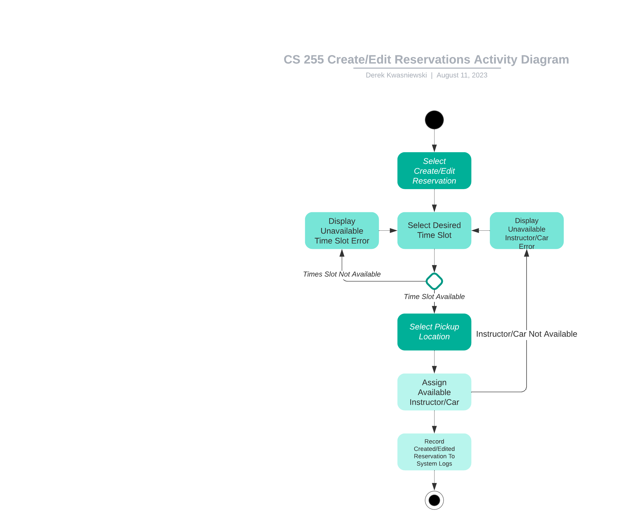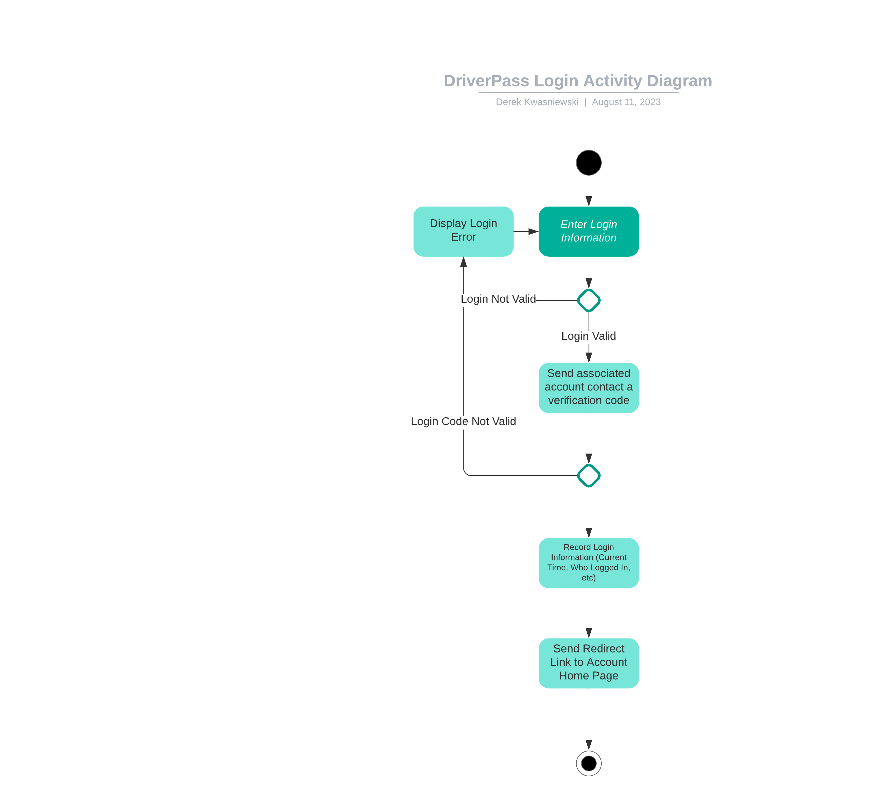

### A screenshot of a computer Description automatically generatedUML Sequence Diagram

### UML Class Diagram

## Technical Requirements

Based on the diagrams created and the performance requirements that were understood at the initial interview, the required hardware will be very limited as this will be a web-based application stored in the cloud. Due to this, research must be done on cloud-based applications that will be able to be accessed by users on multiple platforms including mobile. The cloud-based system must be adaptable because as time goes on more users will be on the system so storage for user data must be able to be increased to handle this. Some software and tools necessary on this system will be those that will be able to keep a constant track of current local DMV laws/rules, and this if these change, appropriate changes must be made to the system as well as a notification to admins to ensure that online classes and videos still meet the new changes. The system must also have enough internet to transfer data for the streaming of videos to users and could also give users the ability to download course information so they can review it offline. System administrators must have their own PC that will be able to access the system to do any repairs or changes as problems arise.